HFA Android App

USER’S MANUAL

Team Members:
Joshua Reisenauer
Muhammad Khan
Binh Vu
Jerry Arnold

ECS 4485.502

November 20, 2010
Revision Sheet

Release No. | Date | Revision Description
1.0 | 11/20/2010 | Initial Revision

USER'S MANUAL

TABLE OF CONTENTS

Page #

1.0 GENERAL INFORMATION 1-1
1.1 System Overview 1-1
1.2 Authorized Use Permission 1-1
1.3 Points of Contact 1-1
1.3.1 Information 1-1
2.0 SYSTEM SUMMARY 2-1
2.1 System Configuration 2-1
2.2 Function Flows 2-2
2.3 User Access Levels 2-3
2.4 Contingencies and Alternate Modes of Operation 2-3
3.0 GETTING STARTED 3-1
3.1 Extracting from the .ZIP archive 3-1
3.1.1 Install Web Service Component 3-1
3.1.2 Install Windows Service Component 3-1
3.2 Starting the Application 3-1

GENERAL INFORMATION

1.1 System Overview

The characteristic challenges and opportunities of mobile services design have recently led software designers to hold the theory of presence, as evidenced by many white papers.

HFA comes as one of the few Android mobile apps in patient centric healthcare industry. HFA provides a valuable access interface to OpenEMR system in Android Market. Over 130,000 download strong user’s community, HFA Android app interface is a breeze look for clinician users of OpenEMR system.

This HFA user’s manual describes the app functions, uses, and support information. HFA is an application for the Google android phone. Data access is required to use this application, all data queried from the database encrypted form. The doctor must first have an account with the database before using this application.

HFA application is intended to assist data retrieval services for quick clinical evaluations, as the data entered and saved by different levels of users, parsing the terms and prompting the clinician user for any abnormalities. Secure content delivery of the OpenEMR database fields is finally returned with critical parameters marked for quick and easy data access. The instance based navigational queues render the secure data calls (programmed by the system developers on the server side) demonstrate the technical aspects of it HIPAA compliance.

The delivery of patient data to the HFA application is designed for easy, secure, and reliable OpenEMR system access on Android. Similarly, the upcoming releases of this app will cover new features like sharing critical data with necessary clinicians, doctors and other medical personnel. Numerous other real-world examples illustrate the need of such mobile application services.

Since, HFA provides a value added service with pre-established OpenEMR system. HFA administrative possesses are managed by site administrators. Easily recognizable user interface and quick deployments make it possible for the program to set and go in few easy steps.

The HFA application has been implemented in two-tiered service architecture. A user request from Android device executes a query at the server side. Communicates directly with a web server through middleware function calls send/receive external requests directly from client processes.

The HFA app delivers database information, parse incoming data streams, and produce a quick view of some key areas of OpenEMR system.

1.2 Authorized Use Permission

Usage of this app is limited to its owner practice/facility via the terms of its development. HFA is wholly owned by the Muhammad, Jerry, Binh, and Josh, and may not be used or referenced without their express consent.

1.3 Points of Contact

1.3.1 Information
Our information goes here

SYSTEM SUMMARY

2.1 System Configuration

System Diagram

The system is connected via a 3G or a wifi connection. Since, data calls that send/receive data entirely connects within a predefined OpenEMR system, it provides Android interfaced of the data with limited functionality. Local fields, variables, and other data sources are initialized by the system during startup, and then updates/populates relevant information from web queries (For instance, the OpenEMR domain)

Step by Step Tutorial
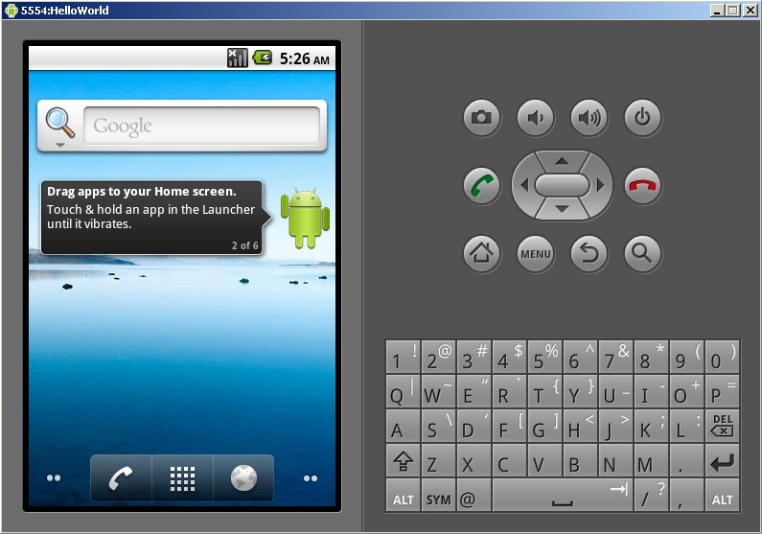

-When Main Menu is loaded click on the middle button on the lower portion of the screen. This will load up the app listing page.

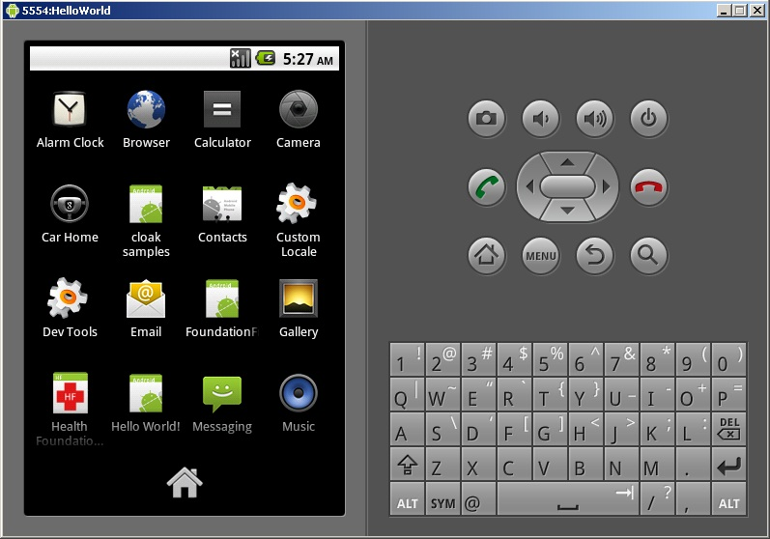

-When app listing page has loaded it should have a little icon in the list named health foundation with a red cross on it. Click this icon, it will load health foundation.

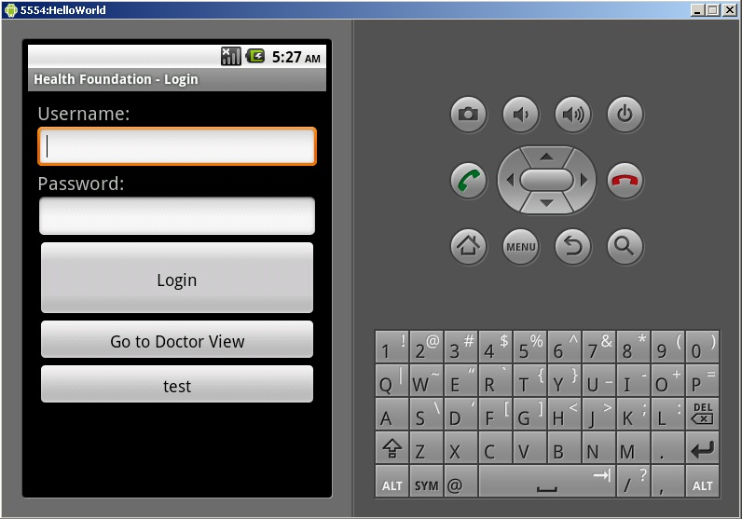

-When health foundation has loaded the menu similar to the one above will appear. Enter your user name and password and click login. If you do not currently have an account set one up through the database website. When you log in it will automatically move you into the Doctor menu.

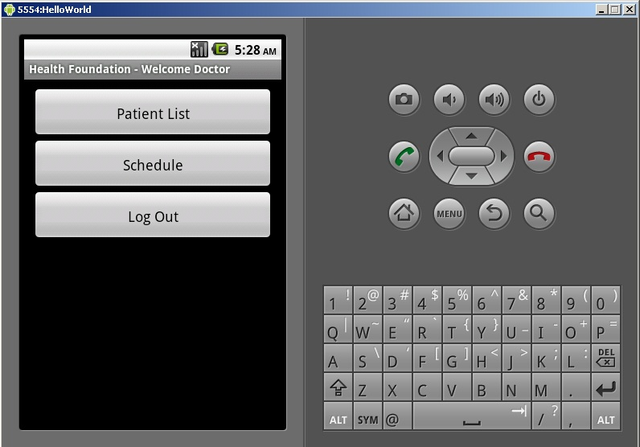

-The doctor menu will look like the one above. Clicking on patient list will show you a listing of all patients including the patients of other doctors in your database. Clicking schedule will open a menu allowing you to create/edit/delete calendar entries. When done using health foundation always make sure to return to the doctor menu and click log out.

-Patient list menu will look like the above picture. Moving your finger across the screen vertically will scroll the list entries. Selecting a name in the list will open the patient menu for that particular person.

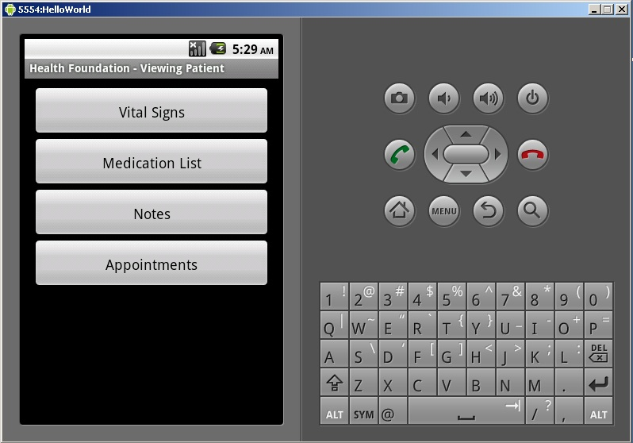

-For the patient menu. Clicking vital signs will display patients temperature, code, body mass index and date it was taken. Medication List will display Drug name dosage, units, and current prescription status. Notes are for notes about this patient which can be viewed by all other doctors of this patient. Appointments will display a list of appointments this patient is scheduled for.

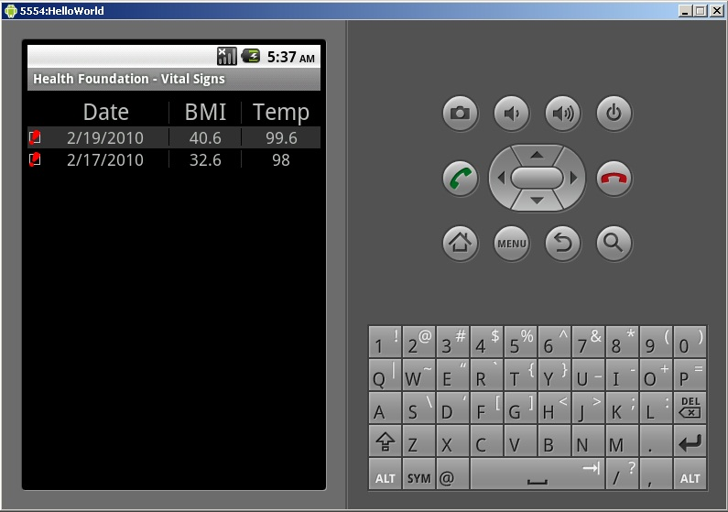

-The vitals menu will display individual vital sign measurements, sorting date in descending order by default.

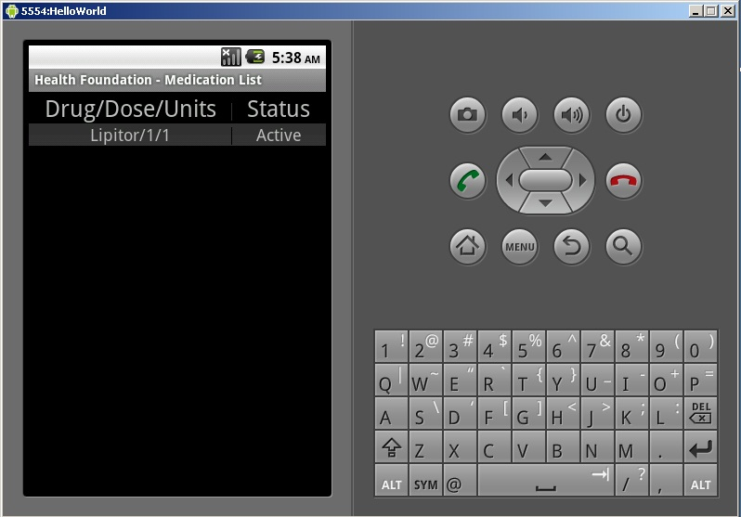

-For medications menu, Status/Drug/Dose/Units are displayed. Active medications are listed first.

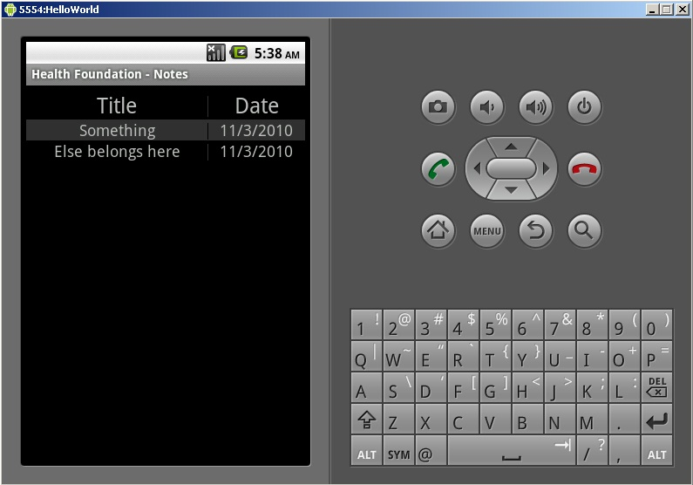

-Patient notes menu above will display all notes made by doctors for this patient. All notes are sorted by date by default. To add a note go to the off screen menu interface to click add. To edit or delete simply click on one of the notes.

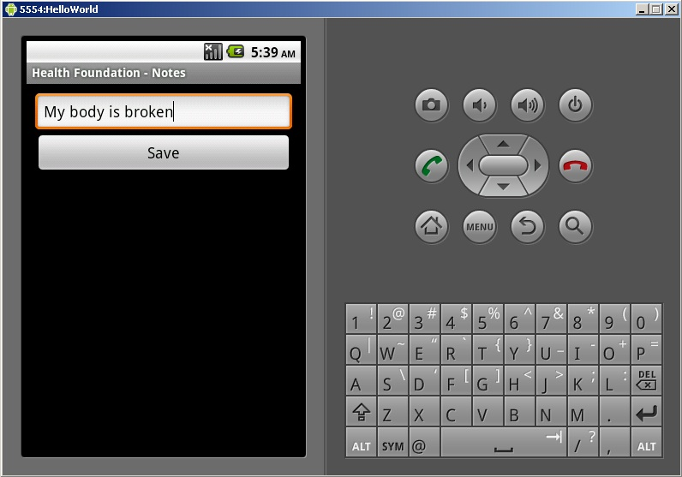

-When a note is clicked it might just look like the one above. Clicking save will update the note to the database.

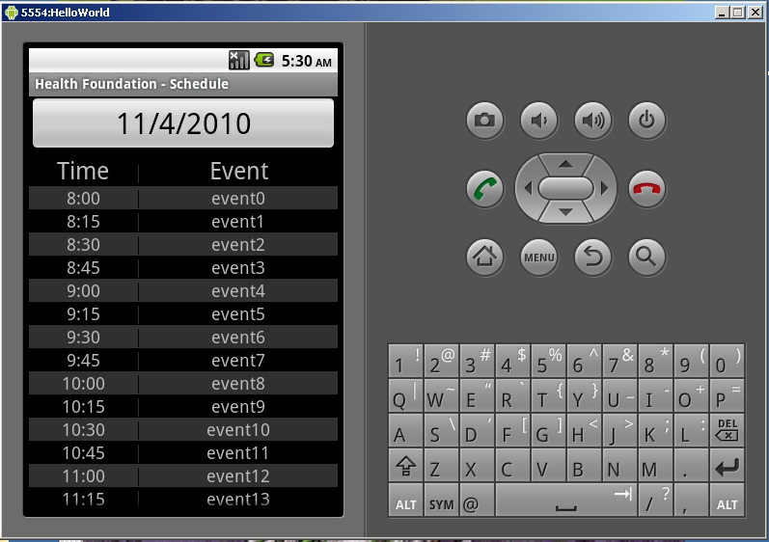

-The schedule in the doctors menu will look like the picture above. Listed by time by default, to add a new schedule entry click the big button with today's date listed on it. To modify or delete a previous entry simply click on one of the entries.

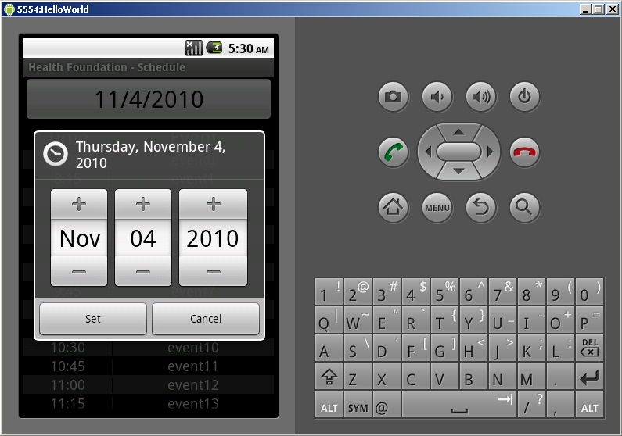

-When you clicked on the big button from the previous page it will load a calendar cog like the one above. Choose the approximate date for an upcoming event and click set. This will generate a hollow event entry now another menu will pop up asking for an event description.

Structure of Application
The team started with the idea of a mobile phone medical record app and expanded it into the set of following requirements.
  - Build a framework on the java android platform that could be used to create medical record applications.
  - Build a test application to show off the functionality of the framework.
  - Integrate the application with OpenEMR, Microsoft Health Vault, and Google Health medical record systems.
  - Incorporate encryption for every data transmission.
  - Design a user interface system to allow seamless navigation.

As the team further designed the project we realized that the original plan to build a framework for accessing medical record apps on Android was not feasible. the Team instead set it’s sites on creating a mobile app, that employed all the features the framework would have. The team restructured some of the initial requirements and came to the conclusion that only one database system was needed for this project. OPenEMR was ultimately chosen as the database that would be used because of it was open source.
The team assembled a list of use cases [look at document all-use-cases]. From the use cases we built a UML diagram [see Appendix A.1.1]. We centered the application logic around a series of list menu’s each of which progressed to a deeper level. Doctor view is a list that takes you to a list of patients or a list of schedules. Patient list takes you to each patient view which in turn offers choices to see sub lists like vital signs or medication list. Square buttons are used to present a menu and a grid of boxes on a black background used for lists. User interfaces were designed from the use cases [See Appendix 2]. Login prompt was designed with a clean and simple look. Doctor and patient views only had buttons each equidistant from each other. All the other views where based off of the list view and broken down by query data pulled from tables in database.

Development of Application

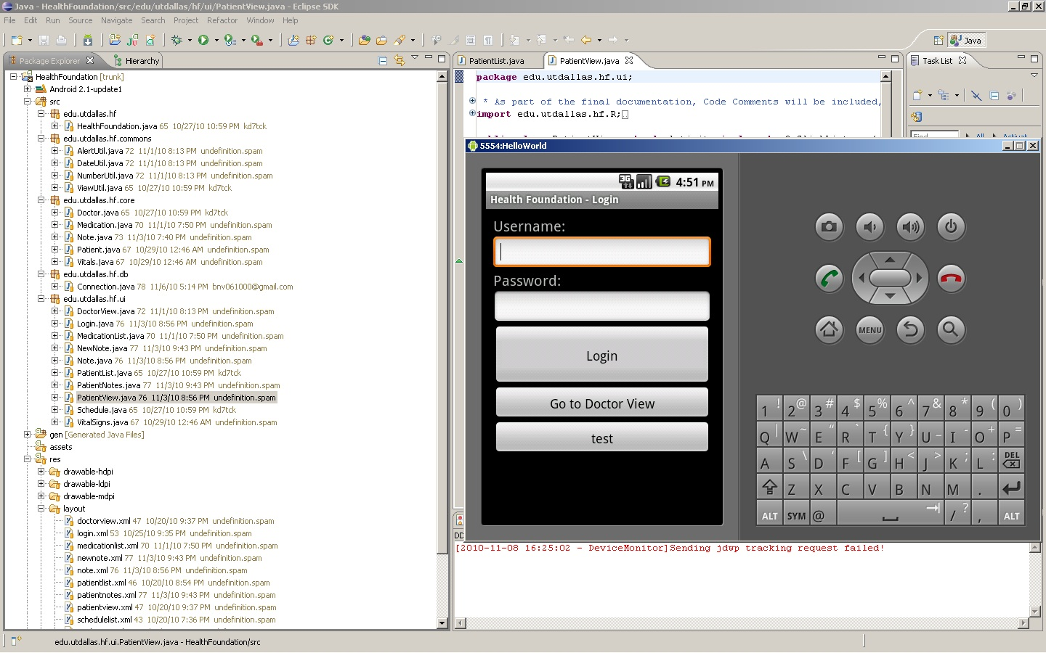

Development of Health Foundation was done in eclipse IDE using Android SDK version 2.1. A version control system was set up with google code under eclipse labs named testehr. Android SDK emulator was used to test the application in a virtual environment and two android phones where used for testing the app in real world circumstances. Development work for the project was split accordingly. Jerry Arnold did most of the coding and UI. Muhammad Khan did database queries, database structure and a little of the coding. Binh Vu did the php server side database calls and some of the app coding. Joshua Reisenauer did the documentation and a little of the coding.
Part way into development the team discovered there was no mysql connection drivers for Android SDK. The team weighed it’s options and determined it would be simpler to create a php server side app to act as a middle man between the app and the mysql server. The client side sends a command option to the php app or server side and depending on what command was sent a series of queries are generated by the client and sent to the server side. The server side will then pass the queries to the database, pull all related records and forward each back to the client side.
Towards the end of development the team members decided there was not enough time to complete some portions of the project. The Lab and Lab review portions where not completed, the team felt due to time constraints this portion would most likely be the most difficult to implement. Another change made to the original scope of the project was the addition of a php serverside app that acted as a middle man to the database for the application. Mysql drivers are not included by default in Android, thus it was necessary to create a server app to pass queries for us.

Appendix
A.1.1
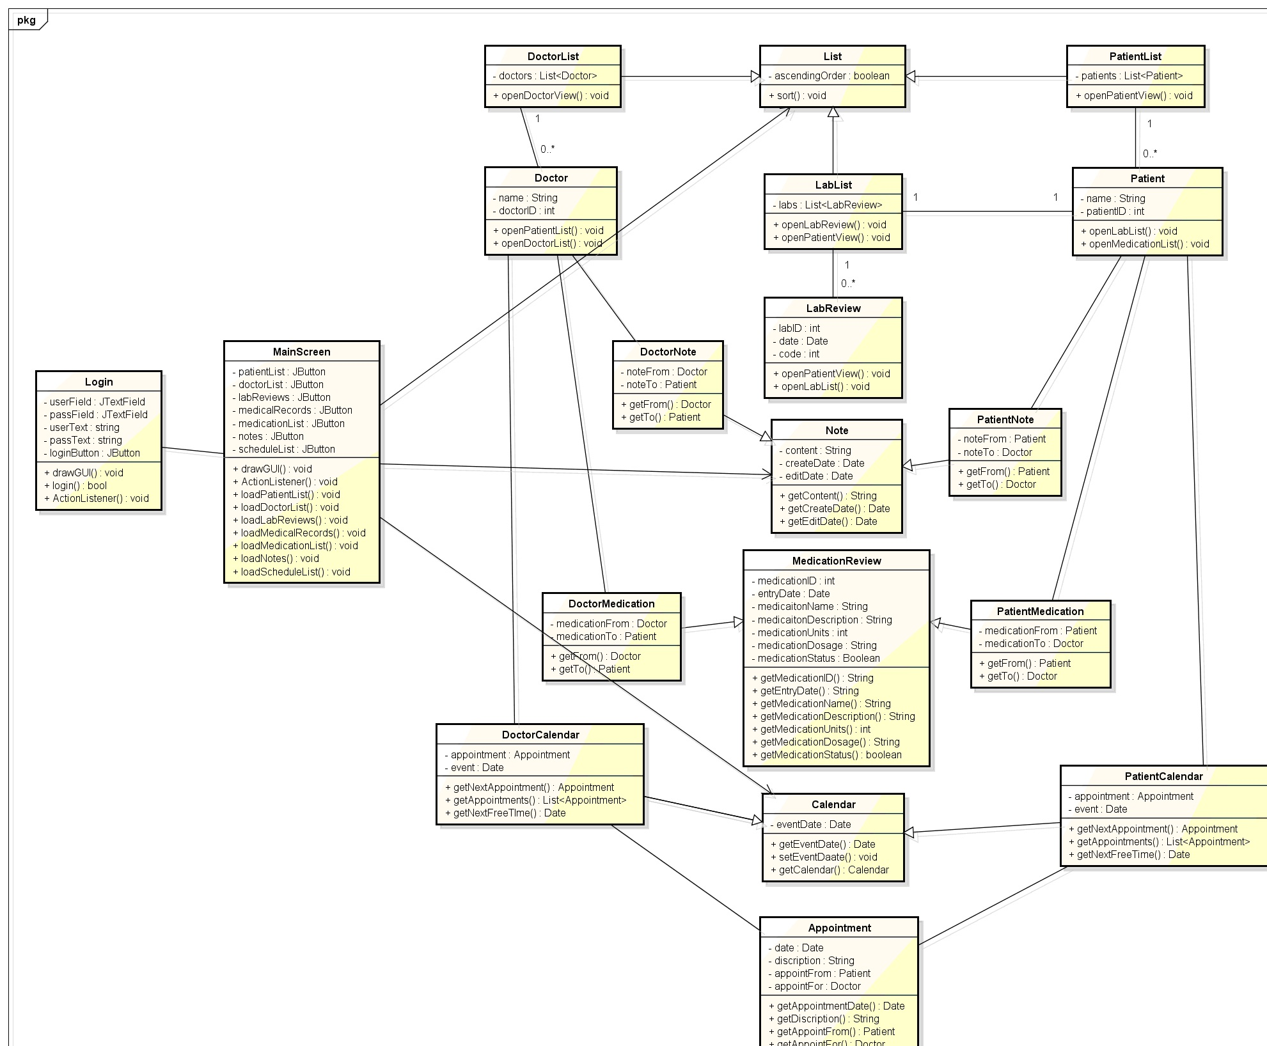
-UML diagram.

A.2.1
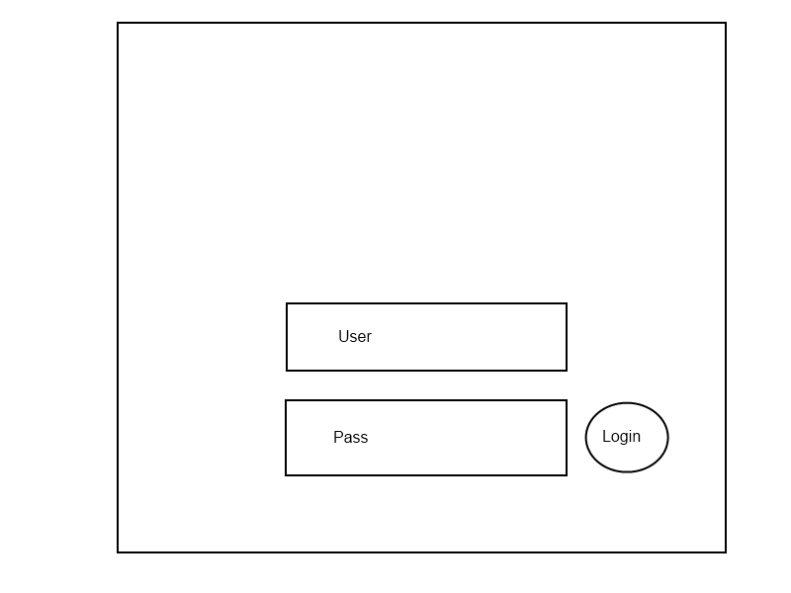
-Login Prompt (2.2)
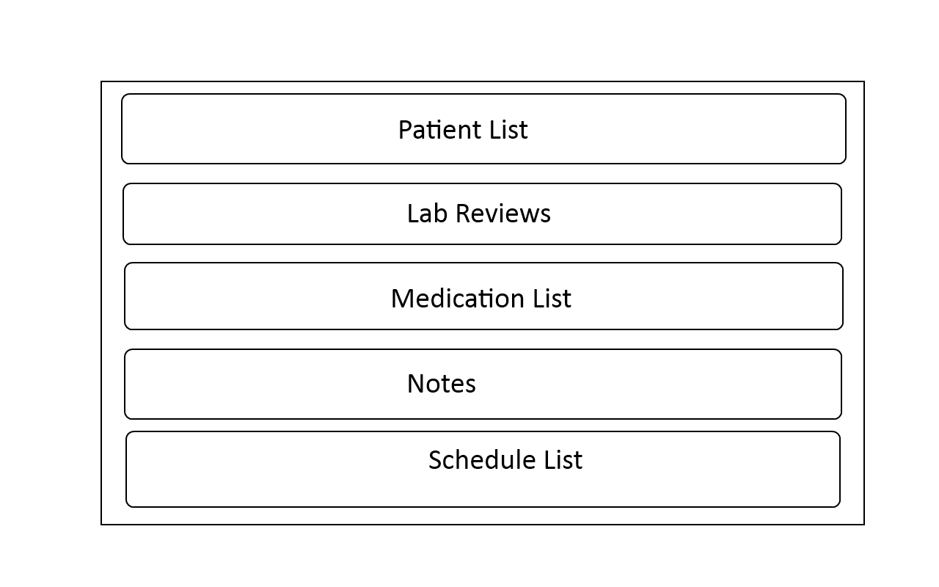
-Doctor View (2.3)
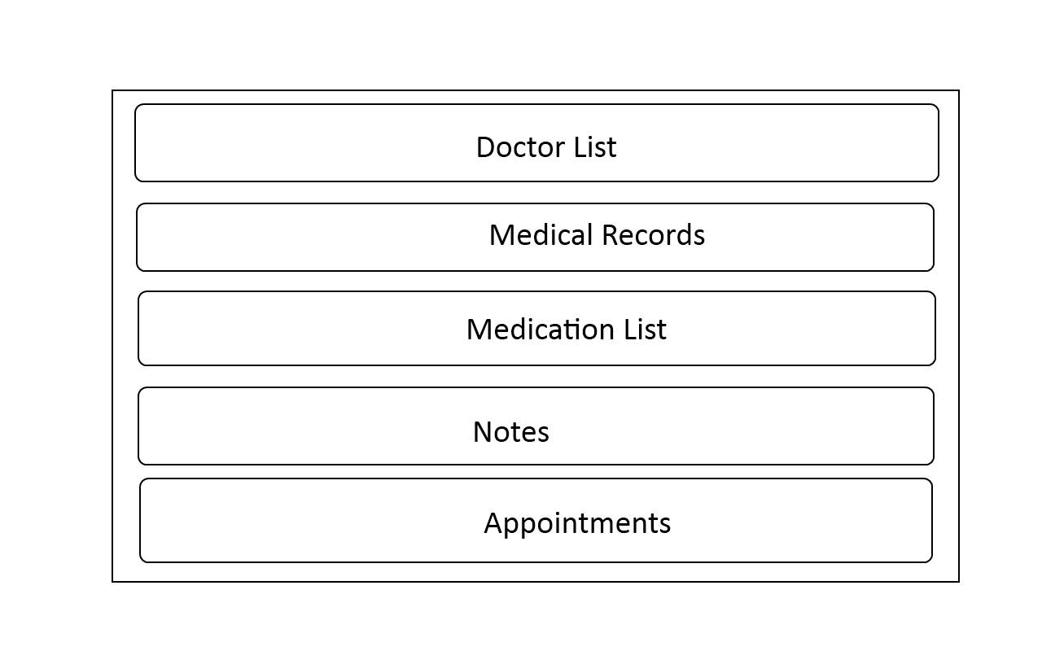
-Patient View (2.4)
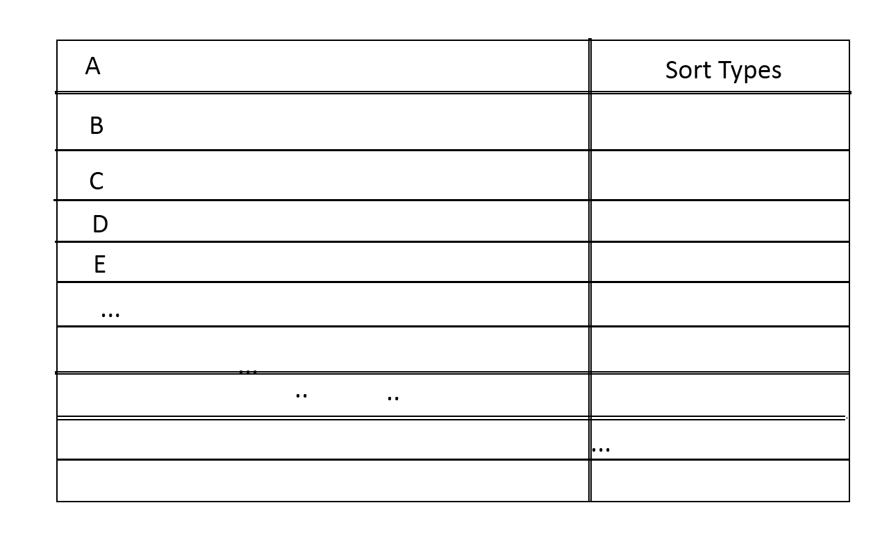
-List View (2.5)
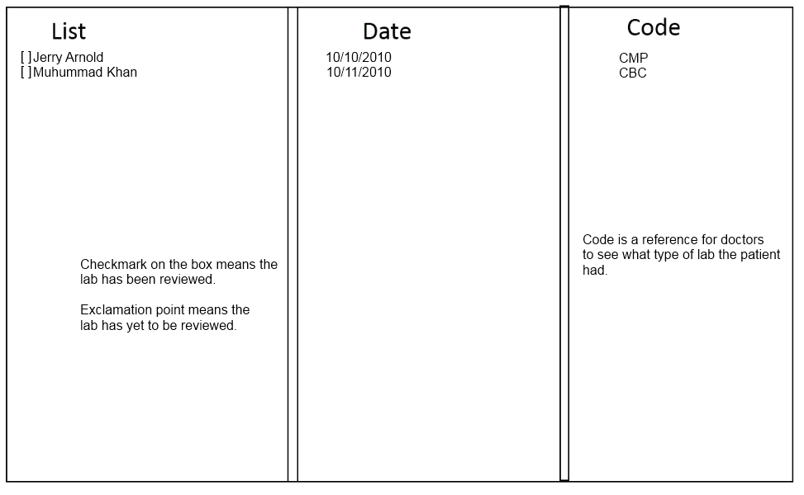
-Lab Review (2.6)
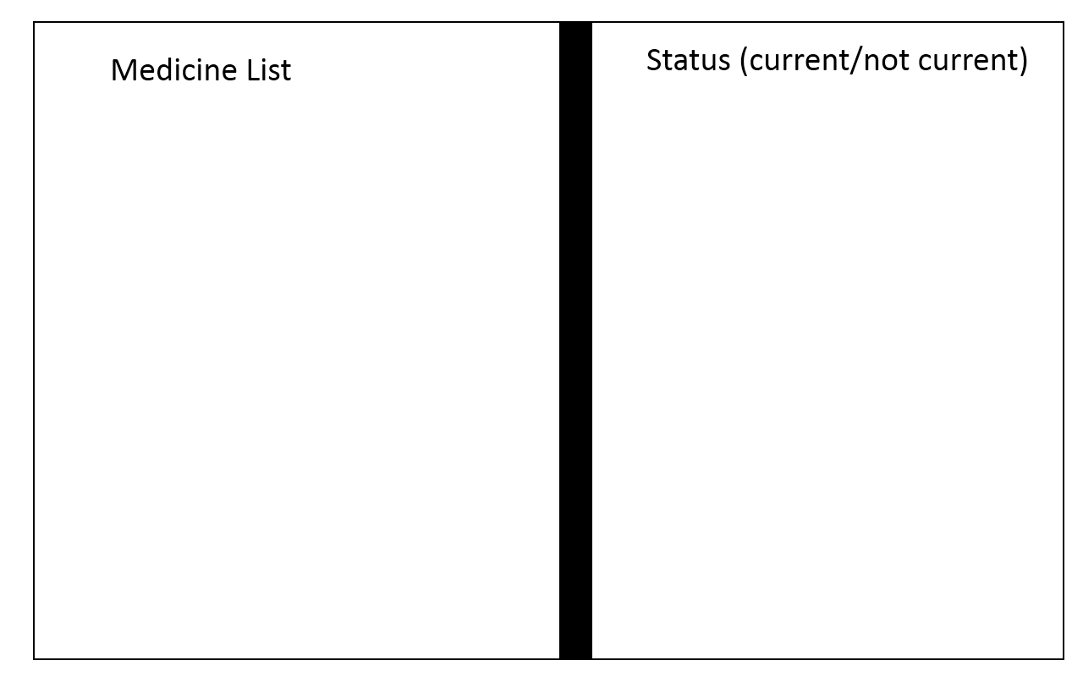
-Medication List (2.7)
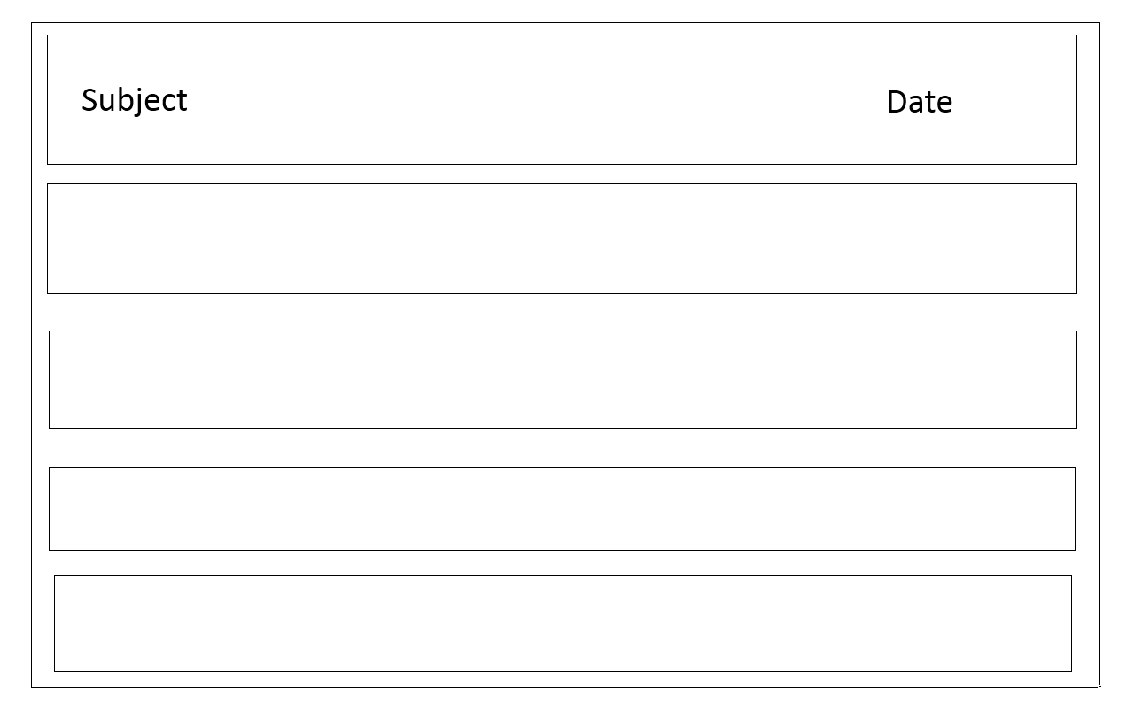
-Screen Notes (2.8)
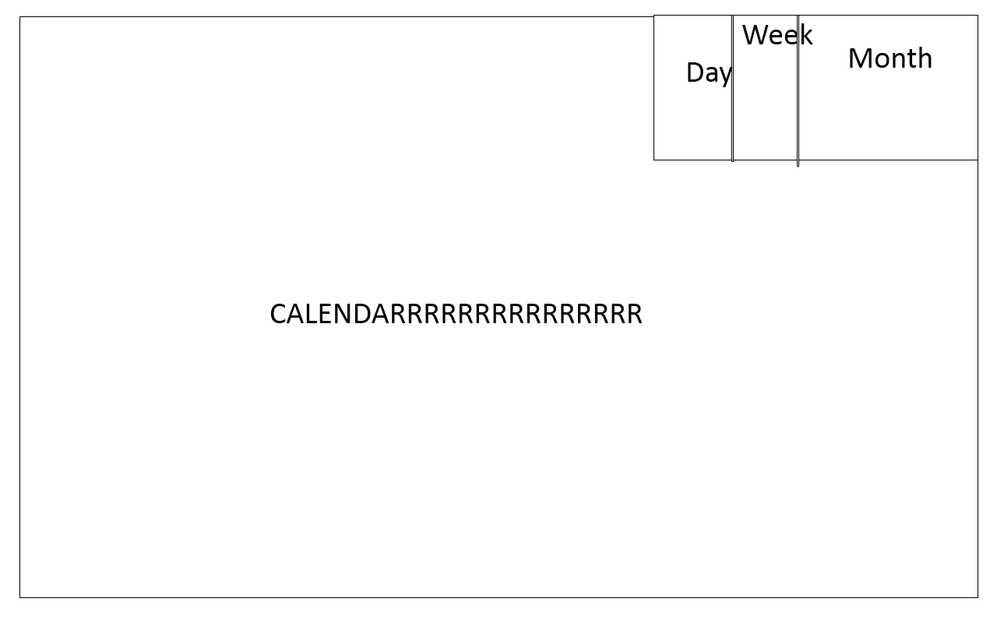
-Screen Calender (2.9)

